Freya – Website content
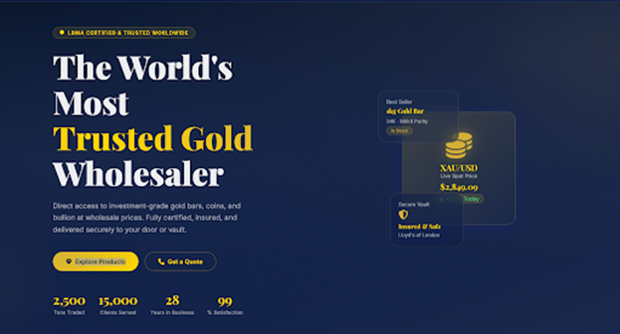
Page 1 -
Top Accent - DIRECT REFINERY SUPPLY | UAE • INDIA • SINGAPORE • HK • BAHRAIN
Main heading - The World's Most Trusted Gold, Silver& Diamond Source
Sub-headline - Direct wholesale access to physical gold, silver, and certified diamond Jewellery. Fully insured, globally compliant, and trusted by top retail brands since 1992.
Buttons - Explore products & get a Quote
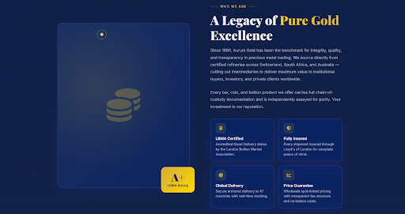
Page 2 -
Who we are - Direct Global Access to Gold, Silver & Diamonds
SuGandh Group is an international trading and manufacturing powerhouse built on long-term industry partnerships. We bypass traditional broker networks to connect our B2B clients directly with refined physical products, maximizing margins for businesses in the UAE, India, and beyond.
Everything leaving our facilities carries independent certification and absolute proof of origin. We don't just supply precious commodities we protect your operational standards.
Title: Trusted Purity
Guaranteed high-purity standards across all gold bars, silver bullion, and certified gems.
Title: Fully Insured
Secure, end-to-end transit insurance on all high-value shipments for absolute peace of mind.
Title: Global Hubs
Direct B2B trading networks connecting the UAE, India, Singapore, Hong Kong, and Bahrain.
Title: Wholesale Pricing
Transparent, competitive market rates straight from our manufacturing and refinery sources.
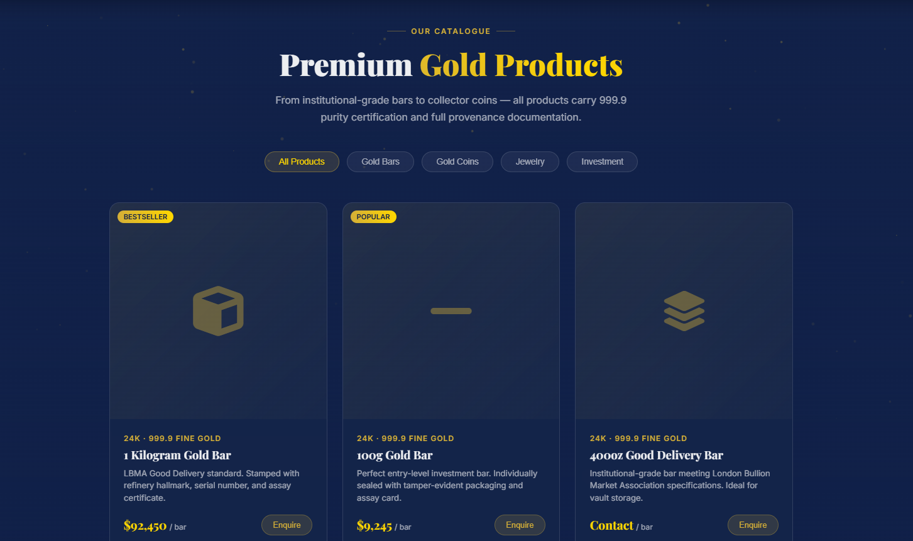
Page 3 -
OUR CATALOGUE
Heading - Premium Wholesale Products
Sub-headline text - Certified bullion and fine jewellery with guaranteed purity and full authenticity documentation.
Filter Buttons - All Products | Gold Bullion | Silver Bullion | Diamond Jewellery
Card 1 Tag: BESTSELLER
Purity Line: 24K - 999.9 FINE GOLD
Product Title: 1 Kilogram Gold Bar
Description: Minted and casting bars meeting international delivery standards. Stamped with refinery hallmark and serial number.
Price / Action: $XX, XXX / bar | Enquire
Card 2 Tag: POPULAR
Purity Line: 999 FINE SILVER
Product Title: 1000g Silver Bullion
Description: Fine silver trading bars and cast bricks optimized for high-volume B2B investments and enterprise portfolios.
Price / Action: $X, XXX / bar | Enquire
Card 3 Tag: NEW EXCLUSIVE
Purity Line: 18K & 22K CERTIFIED
Product Title: Wholesale Diamond Jewellery
Description: Meticulously crafted design layouts and loose diamond parcels sourced directly for global retail jewellery houses.
Price / Action: $X, XXX / bar | Enquire
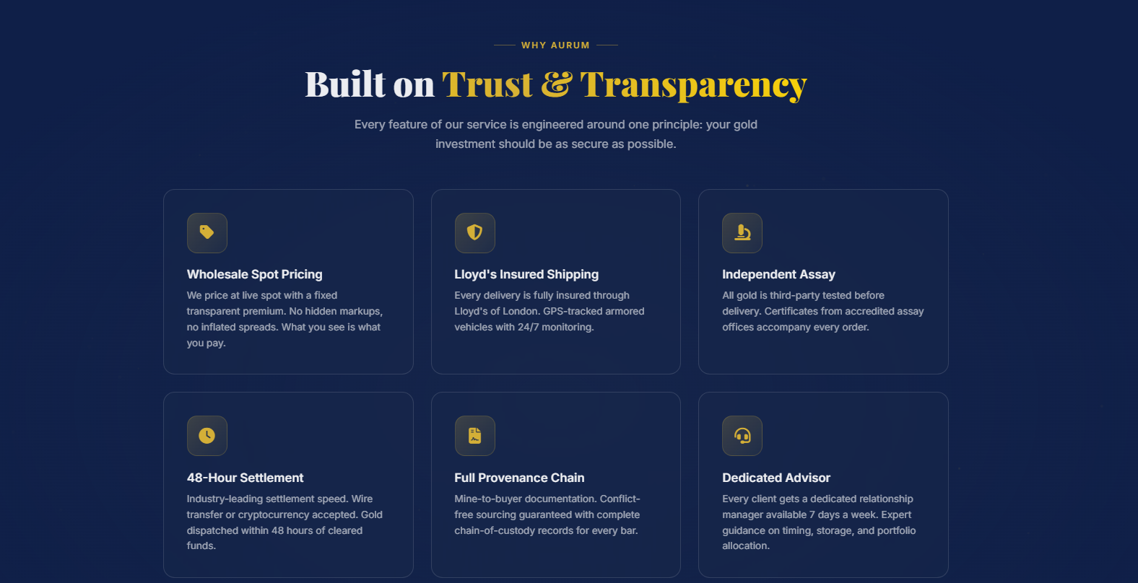

Page 4 -
Why Us
Main Heading - Built on Trust & Quality
Sub headline - Every feature of our service is engineered around one principle
your physical asset trade should be as secure and seamless as possible.
Card 1 - Wholesale Market Pricing
We trade at competitive wholesale market rates with a fixed, clear premium. No hidden markups and no inflated spreads.
Card 2 - Insured Global Shipping
Every delivery is fully insured from refinery to vault. Safe, monitored logistics across our 5-country trading network.
Card 3 - Certified Purity
All gold, silver, and diamonds are strictly verified. Official certification and clear grading reports accompany every single order.
Card 4 - Efficient Settlement
Industry-leading transaction speeds. Direct secure bank transfers processed swiftly to ensure timely allocation and dispatch.
Card 5 - Strict Chain of Custody
Source-to-buyer accountability. Conflict-free gold and ethically sourced diamond tracks with reliable provenance records.
Card 6 - B2B Support Desk
Every partner receives dedicated corporate account assistance. Expert corporate guidance tailored for major retail jewelry brands.


Card 7 - Global Compliance
Fully licensed and regulated across the UAE and key international hubs. Strictly compliant with local AML/KYC guidelines.
Card 8 - Liquid Buy-Back
Guaranteed liquidity option to trade back assets at live spot market rates with zero friction when you need it.
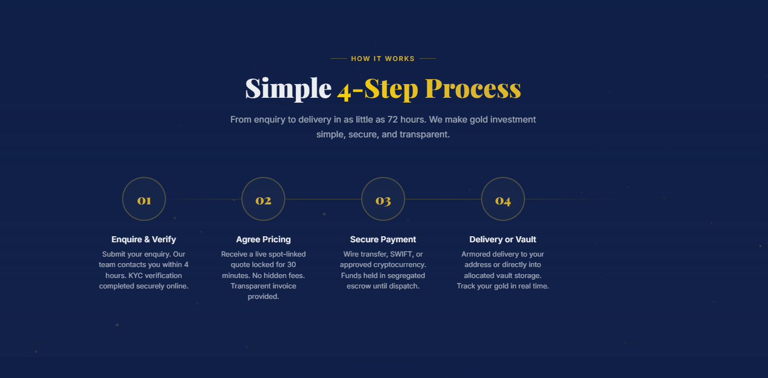
Page 5 -
How it works
Main Heading: Simple 4-Step Process
Sub headline: Streamlined B2B trading from initial corporate inquiry to secure global fulfilment.
01. Connect & Verify
Submit your business inquiry online. Our trade desk will contact you promptly to complete your account setup.
02. Lock Market Rates
Receive a live market-linked price quotation tailored to your volume with complete invoice transparency.
03. Secure Settlement
Finalize your trade via secure bank wire or SWIFT transfer to instantly lock in your inventory allocation.
04. Insured Delivery
Your certified precious metals or jewellery order is securely shipped and delivered directly to your facility.
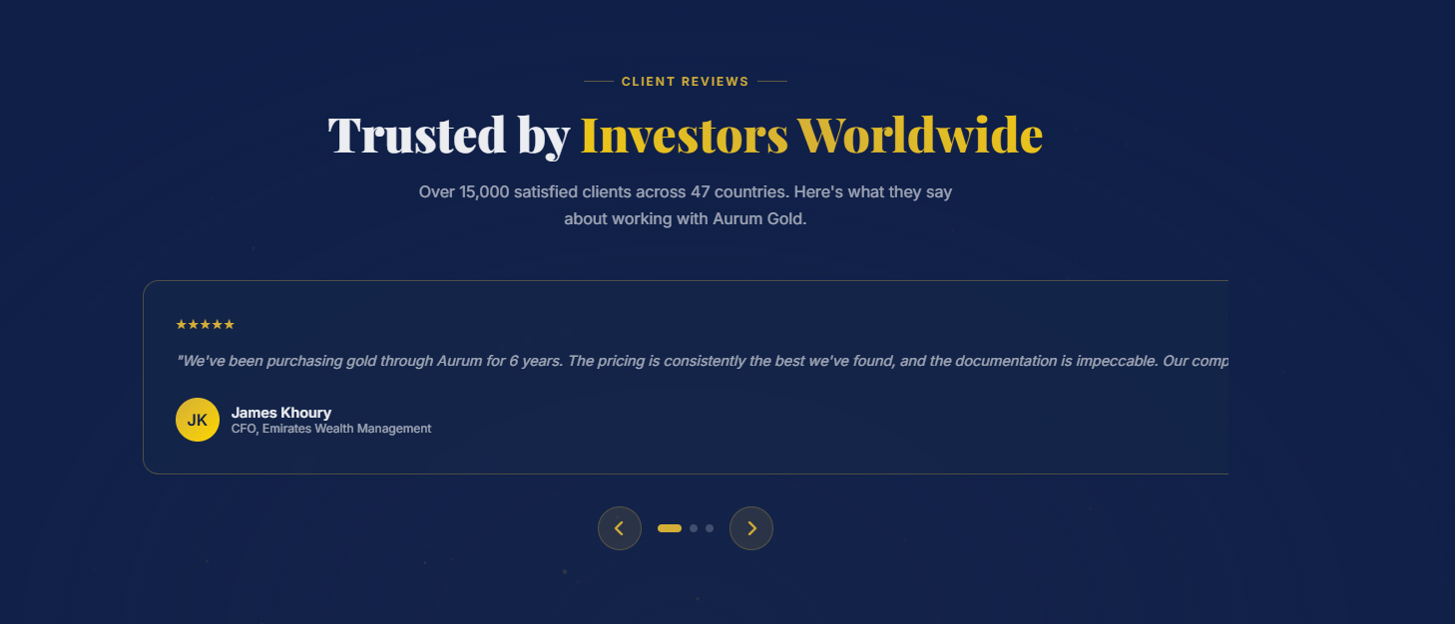
Page 6 -
CLIENT REVIEWS
Main Heading - Trusted by Partners Worldwide
Sub-headline - Powering leading jewellery houses and institutional traders. Here are why businesses choose SuGandh Group.


Page 7 -
GET IN TOUCH
Main Heading - Ready to Secure Your Supply?
Sub-headline - Request a free, no-obligation wholesale quotation today. Our global B2B trading desk is standing by to assist with your custom volume requirements.
Primary Button - Request a Quote
Secondary Button - SuGandh Number
Trust Ticks - No Obligation | Rapid Response | Strictly Confidential

